2 February 2007 The Weekly Bulletin of Rotary Club of Kathmandu Mid-Town Bc # 31 of 2006-07
Rotary Club of Kathmandu Mid-Town
Breakfast Chatter




District : 3290 Web: www.rotarymidtown.org.np Club Id : 26776

FEBRUARY IS WORLD UNDERSTANDING MONTH
Advancing world understanding and peace, which is expressed in the fourth part of the Object of Rotary, is an important focus of Rotarian service. It is the impetus for numerous service efforts and other cooperative ventures among Rotarians from different parts of the world. It is the reason Rotary International has a long-standing, close collaboration with the United Nations and many of its member agencies. Appropriately, every year the anniversary of the founding of Rotary, 23 February, is celebrated as World Understanding and Peace Day.

Ms Amanda Rader talked about RI World Peace Fellowship
at the Club meeting on 26 January 2007.
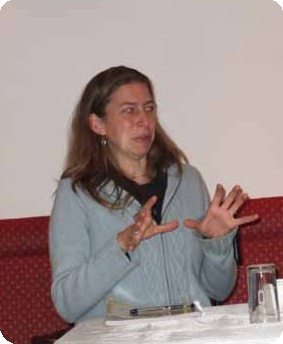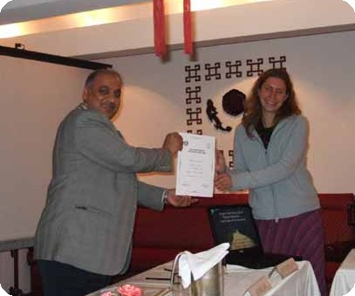
a) Amanda Rader talking to club members during her presentation;
b) Guest speaker Amanda smiles while receiving a Letter of Appreciation from President CK Golchha.

Weekly Meetings and Programs :
Date | Program/Speaker | Program/Topics of Presentation
2 Feb 2007 | Dr Narayan Manandhar | Corruption and development
9 Feb 2007 | Buddhi N Shrestha | Border management
16 Feb 2007 | Club assembly | Club assembly
23 Feb 2007 | No meeting | Weekly meeting combined with picnic on 24 Feb
24 Feb 2007 | Weekly meeting cum picnic | Sankhu

Friday, 2 February :
Dr Narayan Manandhar, anti-corruption advisor at Danida, will be talking on 'corruption and development' providing recent data on corruption from Transparency International and HDI from UNDP. He will discuss their inter-relationships and current issues. He will also provide cartoon presentation.

Dental Awareness Camp at Ramkot :
The Club is going organize a dental awareness camp at Ramkot on Saturday, 3rd Feb 2007. The program is being coordinated by Rtn Dr Neil Pande in cooperation with Jayanti Youth Club, Ramkot.

Career Counselling at Ramkot :
On Saturday, 3rd Feb 2007, the Club will be conducting Career Counselling sessions for the students of Sitaram Madhyamik Higher Secondary School at Ramkot. Select Club members will be volunteering to share their professional experience and expertise with the students on various professions. The program is being coordinated by Vocational Service Director Govinda Chipalu.

On Lighter Side : Click at the figure ⇩


As we go through our lives at work, at home, and in our communities, we must be conscious of our responsibilities as Rotarians:
to speak the truth, to be fair, to build goodwill and better friendships, and to always try to do the best we can for everyone we encounter.
RI President William B. Boyd

2 February 2007 The Weekly Bulletin of Rotary Club of Kathmandu Mid-Town Bc # 31 of 2006-07

Editor: RR Shrestha, Club Service Director email: rryes@wlink.com.np

